Coding Task 1 screenshot:
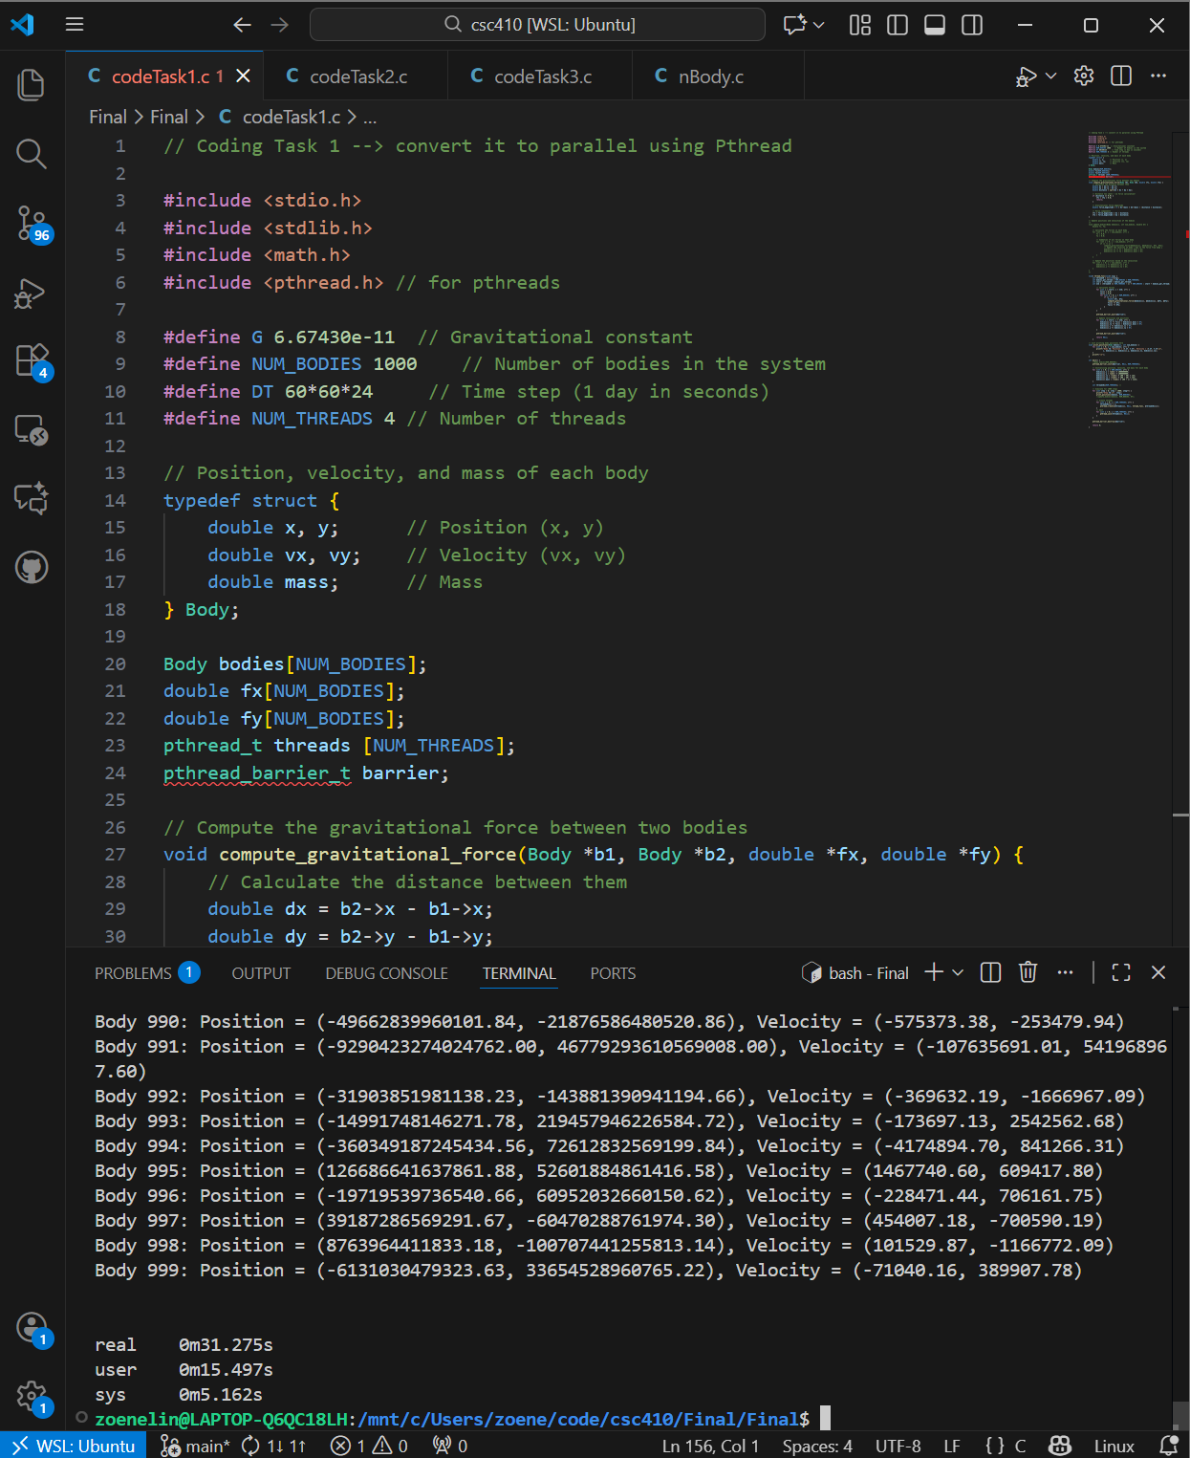

Coding Task 2 screenshot:
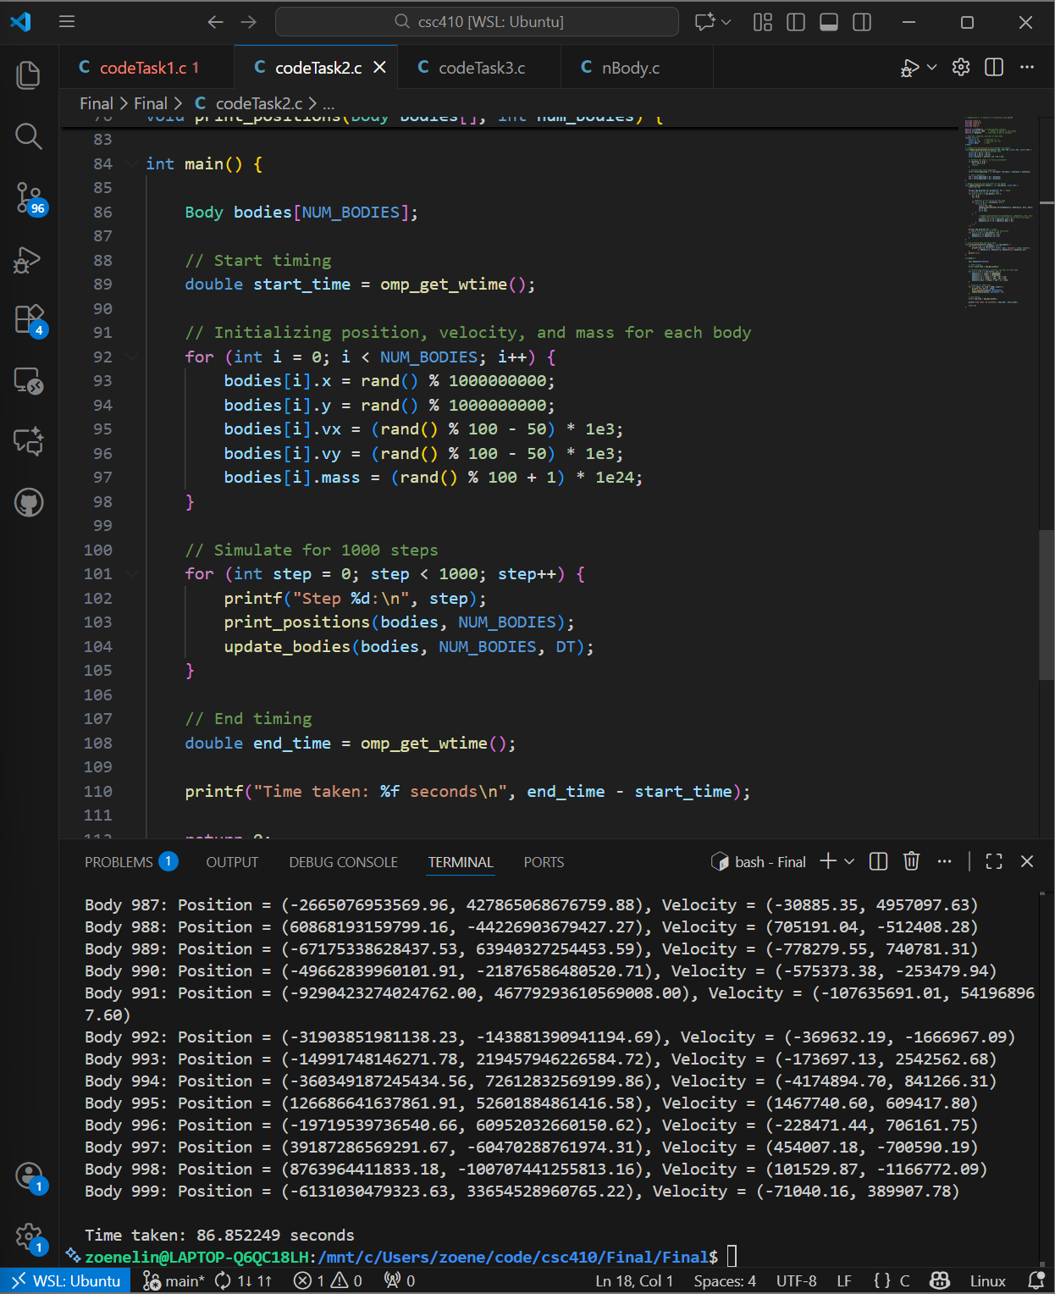

Coding Task 3 screenshot:
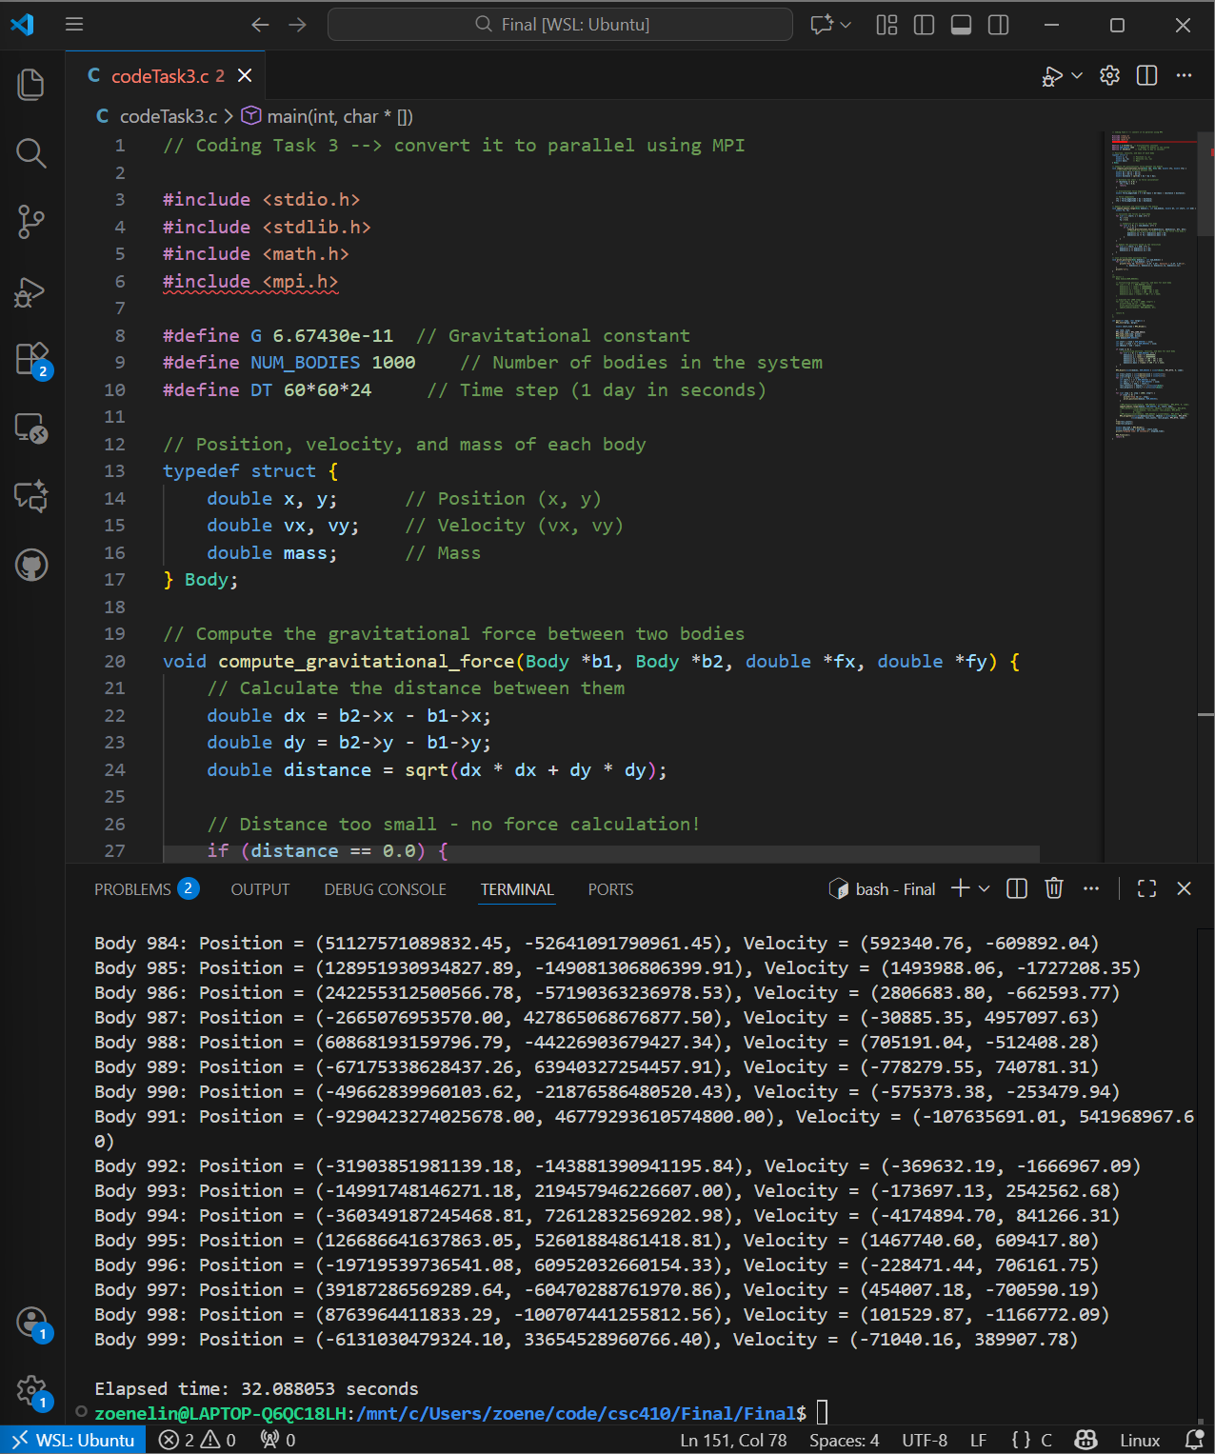

Coding Task 4 screenshot:
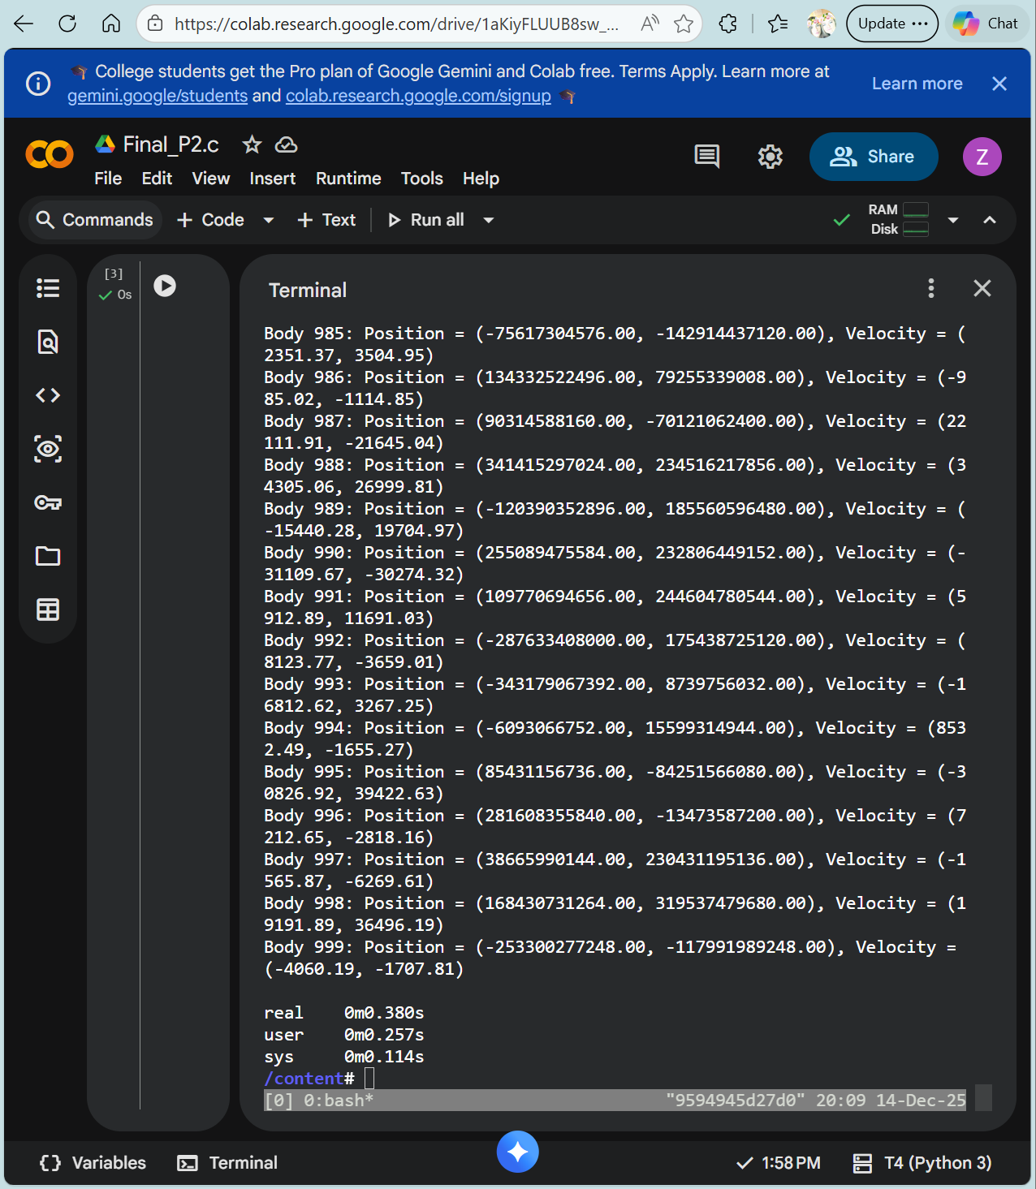

Task 5 Benchmarked times for sequential and parallel versions
Sequential | 34.773s
Pthreads coding task 1 | 31.275s
OpenMP coding task 2 | 86.852249s
MPI coding task 3 | 32.088053s
OpenCL | 0.380s

Task 6:
- How did you partition the work with each tool
Coding task 1 I divided the bodies across threads by dividing the outer loop. Each thread works on its own chunk of bodies and the last thread picks up the remainder if not split evenly.
Coding task 2 I used the #pragma omp parallel for to divide the bodies among the threads and each thread works on its own chunk of force calculations. My second #pragman omp parallel for updates the positions.
Coding task 3 I divided the bodies based on rank and each process updates its chunk of bodies. MPI_Allgatherv makes sure that all the processes had the full updated list at the end.
Coding task 4 I gave each body a “work-item” on the GPU (using google collab) and this allowed thousands maybe more bodies to be parallelized at the same time.

- Explain the necessity of the operations you used in detail for each parallel programming tool
Coding task 1 First I had to create the threads and then give each thread a chunk of bodies to work on. From there I had to use the synchronization barrier to make sure all threads finished their chunks of work before moving onto the next step.
Coding task 2 First I had to use the #pragma omp parallel for as this essentially automates the splitting or dividing up work between threads. Next I had to make variables fx and fy private in order for all threads to have its own copy and ensure no overwriting of values happened. Continuing on, I had to use a second #pragma omp parallel for the updating positions.
Coding task 3 I needed to make sure each process had its own chunk of bodies to work on and then use MPI_Allgatherv so that each process had access to the list of updated bodies after every step.
Coding task 4 First I had to set up kernels to each body on the GPU and use synchronization techniques like clFinish to ensure the kernel finished before moving to the next step.

- Compare and contract each tool for parallelizing the N-body sequential program. List their advantages and disadvantages.
Pthread (coding task 1) The advantages to use Pthreads is the control over the threads it allows you, whether that be synchronization or the management. The disadvantages of using Pthreads is the amount of coding and the fact that the speedup wasn’t significant when looking at task 4.

OpenMP (coding task 2) The advantages of using OpenMP is the ease and minimal coding needed to parallelize the code. In addition, OpenMP is great for shared-memory but the disadvantage is the scalability and based on task 4 again, the performance was actually worse in this case versus the sequential code.

MPI (coding task 3) The advantages to using MPI is when working with distributed memory, scalability, and control over communication. The disadvantage is overhead and in reviewing task 4 the performance gains were marginal.

OpenCL )coding task 4) The advantages of using OpenCL are the extreme performance gains and suitability for parallelization of the N-Body problem. The disadvantages are the learning curve/amount of coding. But all in all the advantage outweigh the disadvantages.

